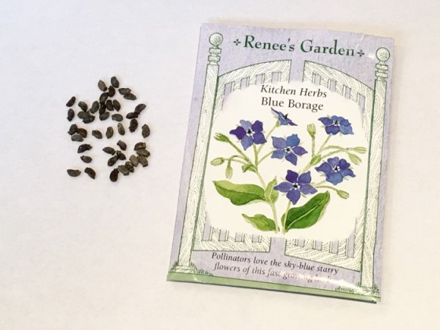
You will need:
One Seed Packet
Pencil
Worksheet

Directions for filling out the worksheet:

- Start with the front of the package. What sticks out to you about the front of the package. What would draw you to plant this particular plant?

- Who is the Seed Company? List the different seed companies of the packets you brought on the board.

- Then look for the type of the plant you would be planting. Usually it is the largest text on the package, but not always.

- Is it an annual or a perennial? What Variety is the plant?

- Look for the other miscellaneous information about the plant on the front. Possible terms include organic, color, butterfly attracting, etc. If it is a flower, what color will it be.

- Then look at the back of the package. This is where a treasure trove of information is located. Look for the date (year packed) or date of freshness.

- Look for things such as planting depth, sun, spacing, days to maturity, height at maturity. Write down on the worksheet all you can find about your plant.

